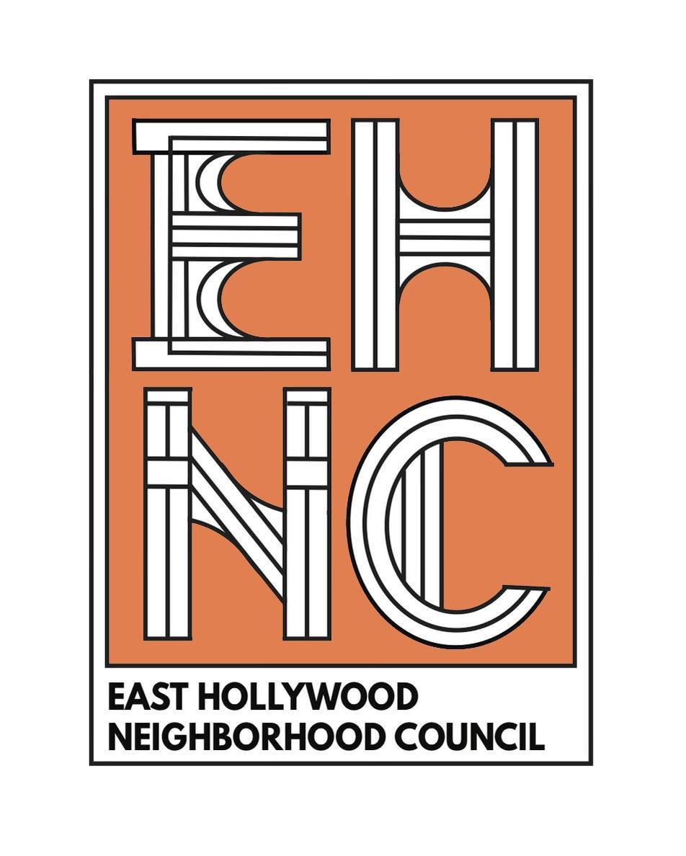  EAST HOLLYWOOD  NEIGHBORHOOD COUNCIL  CERTIFIED COUNCIL # 91  APRIL 19, 2007  P.O BOX 292359  LOS ANGELES, CA 90029  ehnc@easthollywood.net  www.EastHollywood.net  IG: @easthollywoodnc  Facebook: @easthollywoodnc  Twitter: @easthollywoodnc  This Governing Board meets the third Monday of each month at 7:00pm. | CITY OF LOS ANGELES  EAST HOLLYWOOD NEIGHBORHOOD COUNCIL  Governing Board Agenda  Monday, August 19, 2024  7:00PM  Meeting Location  Hollywood Hotel  1160 N Vermont Ave  Los Angeles, CA 90029  Location Information:  PARKING AVAILABLE ON SITE  Enter on Lexington  Ring the intercom and say you are there for the EHNC meeting. Enter through the lobby and take the elevator to the meeting room on the lower level. Ask the concierge for any assistance.  Please be mindful of time - meetings must be over by 10pm.  Via ZOOM  https://zoom.us/j/92805658816  Via Phone: (669) 900-6833  Meeting ID: 928 0565 8816  Executive Chair: Christopher Martinez  Executive Co-Chair: Colter Carlisle  Executive Members: James Bennett, Jeff Zarrinnam, Jillian Schultz & Jack Symington | 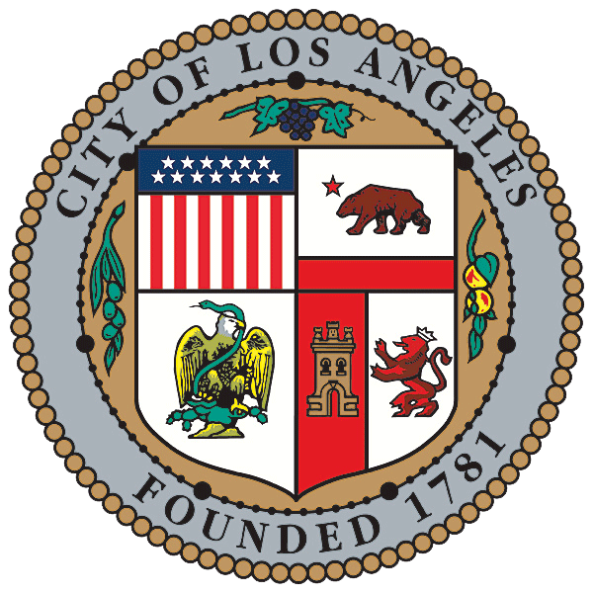  KAREN BASS – MAYOR  GOVERNING BOARD OFFICERS  Christopher Martinez - President  Colter Carlisle - Vice President  James Bennett - Treasurer  Jeff Zarrinnam - Corresponding Treasurer  Jillian Schultz - Corresponding Secretary  Jack Symington - Recording Secretary  GOVERNING BOARD MEMBERS  Doug Haines  Jennifer Lee  Stephanie Park  Mike Sadler  Vicky Olson  Rosie Echeverria  Joshua Kirchmer
VIEWING MEETING: The public may join the meeting by [1] Going to www.easthollywood.net and joining via Zoom (Meeting ID 928 0565 8816) [2] Calling (669) 900-6833 (Meeting ID 928 0565 8816). When prompted by the presiding officer, to provide public input at the Neighborhood Council meeting the public will be requested to dial *9 or use the Raise Hand option, to address the Board on any agenda item before the Board takes an action on an item. Comments from the public on agenda items will be
heard only when the respective item is being considered.

PUBLIC COMMENT: Comments from the public on other matters not appearing on the agenda that are within the Board’s jurisdiction will be heard during the General Public Comment period. Please note that under the Brown Act, the Board is prevented from acting on a matter that you bring to its attention during the General Public Comment period; however, the issue raised by a member of the public may become the subject of a future Board meeting. Public comment for agenda items is limited to 1 minute, with a cumulative total of 3 minutes for multiple agenda items. General public comment shall be limited to a cumulative total of 2 minutes, unless adjusted by the presiding officer of the Board.

- Call to Order

- Roll Call

- Public Comment on Non-Agenda Items
Caller commented on cracks in sidewalk, planters, fire equipment mobility issues [unknown where, what]
Caller commented on cracks in elevator shaft. Fire lane needs to be opened up. [unknown where, what]
Caller from CHLA introduced themselves and asked us to respond to a survey, shared via email
Board member Stephanie Park commented on the meeting reminder email subject, requests it be less accusatory, aggressive.
Olga from CHLA commented on the importance of filling the survey

- Community Reports (2 minutes Per Report and Q&A (1 minute))
Savannah Portillo of SD3 presented a community report
  - CD 13 Report, Office of Councilmember Hugo Soto-Martinez - Karla Martinez Field Rep.
Karla presented the CD13 Community Report
  - Neighborhood Prosecutor - Kurt Knecht
  - Budget Advocate Report - Jack Humphreville
  - LAPD Report
- Senior Lead Officer - LAPD Rampart Division - Ryan Nguyen
- Senior Lead Officer - LAPD NorthEast Division - Antonio Hernandez
- Senior Lead Officer - LAPD Hollywood Division - Annabelle Eubank (South of Sunset/West of Normandie)
- Senior Lead Officer - LAPD Hollywood Division - Mika Gonzalez (North of Sunset/West of Normandie)
  - City of LA Report, Office of Mayor Karen Bass - David C. Nguyen - East Hollywood Field Rep.
  - CA Assembly District 52, Office of Assemblyperson Wendy Carillo - Carlos M. Arce Field Rep.
  - LA County Supervisor Hilda Solis SD1
  - Department of Neighborhood Empowerment, Joel Gonzalez
Joel delivered remarks regarding the happenings at DONE.
  - Los Angeles Public Library - Cahuenga Library, Crystal Noe
  - CA State Senator - District 24, Maria Elena Durazo

- Community Voices (2 min per item)
- Thai CDC Update
- East Hollywood Bid (Jeff Zarrinnam)

- Action Items
Consent Agenda:
- Motion approval of July 2024 Minutes (Symington)

  - Discussion and Update on the Bylaws (Link to Notes)
Joel noted that this update will be ready soon, perhaps within the week
  - Discussion and Possible Action on a Motion to send a letter to Mayor Bass, Councilmember Soto-Martinez, and DONE regarding the restoration of ED-1 projects to the Planning Early Notification Reports as a matter of public transparency (full text HERE) (Carlisle)(10 minutes with Q&A)
Colter and caller Sam Uretsky spoke on the ED-1 issues, ZIMAS dis-integration, asking the Mayor & CD13 to heed the requests of Greater Wilshire NC, EHNC, & other NCs to increase transparency regarding these housing issues.
Board Member Jennifer Lee commented about also being unhappy with the email headline and also expressed confusion about the ADU element of ED-1
The basic jist here is developers are getting structures approved and built as 100% affordable while leaving lots of primo real estate in the building “empty” or marked as “recreation” then converting them to market rate suites kinda thing for mega dollars after the fact; so they’re getting the boons of fully affordable housing builds then swapping them to market.
Caller MonaM also requested better transparency
Caller Sam clarified he’s representing Larchmont United
  - Colter Carlisle would like to motion for reconsideration for the letter we approved regarding the illegal recycling center on Fountain and Vermont.
Colter clarified this is changing to whom the letter is addressed
Doug commented on this agenda item, bemoaned issues about working with LADBS.
Colter commented on this agenda item
Karla from CD13 spoke on this issue, stating that Emma is the lead on this project.

- Budget and Finance Action Items:
  - Approval of the July 2024 MER
  - Discussion and Possible Action regarding re-approving Moore Business Results as EHNC web developer
  - Discussion and Possible Action regarding contributing $500 to the Congress of Neighborhoods
  - Motion to approve payment of $500 invoice from Vanesa Andrade for two completed utility box murals ($250 each) at Normal and Vermont and Santa Monica and Western.

- Committee Reports (1 min per item)

Arts & Culture (Schultz)
Jose presented

Budget & Finance (Bennett)

Business (Zarrinnam)

By Laws, Ethics & Standing Rules (Martinez)

Bylaws
  - Standing Rules (pdf version)

Executive Committee (Martinez)
Chris presented

Homelessness & Displacement Prevention (Sadler)
Colter presented
- Immigrant’s Rights (Sadler)

Outreach (Carlisle)
Colter presented

Planning & Land Use Management (Park)
Stephanie presented

Public Health, Safety & Sustainability (Symington)
Josh presented

Youth & Education (Echeverria)

- Announcements
  - CIS Credentials (Schultz)
  - Update on Produce Box Events for the Future
  - Next Board Meeting on 09/16 and Executive Meeting Date 09/11
  - Update on SB411 (Martinez)
  - Update from President (Martinez)

Adjournment: MEETING ENDS at 9PM

AGENDAS & PUBLIC COMMENT: Public comments on agenda items will be heard when the item is considered. Public comments on other matters within the council's jurisdiction may be made during the Public Comment period. Public comments are limited to two minutes per speaker. Action may be taken on any agenda item except Public Comment, announcements and reports. Actions may be reconsidered only if a motion for reconsideration is adopted at the same meeting where the action was taken. You may request a copy of printed materials that are distributed at the meeting. You may record the meeting by audio, video or photographic means as long as it is not disruptive. Meeting notices and agendas are posted at various locations (see list below). If you believe the council is not following the law or its own rules you may file a grievance in writing with copies to both the Chair and the Secretary. Please be respectful of others, even when you differ with them.

COUNCIL PROCESS: Everyone who lives, works, owns property, attends school, is a member of a faith organization or works in a non-profit organization that provides services within the boundaries of the East Hollywood Neighborhood Council is a "stakeholder." All stakeholders are members of the Council. Stakeholders elect a Governing Board to represent them. This Board is recognized as the decision-making entity by the City of Los Angeles and was elected on March 31, 2019. While the Board is an official decision-making entity, meetings are conducted as much as possible in a town hall format. Committees are open to anyone with an interest in East Hollywood. The East Hollywood Neighborhood Council depends on the active public participation of its diverse, dynamic and unique community for its success.

POSTING SITES: Meeting notices and agendas are posted at the following locations within East Hollywood (three days in advance for regular meetings and one day in advance for special meetings). The official posting is at The Hollywood Hotel, 1160 N. Vermont Avenue and on our website at www.easthollywood.net. The agenda may also be posted at: (1) Armen Realty, 5111 W. Santa Monica Boulevard (2) Stakeholder Residence, 772 N. Kenmore (3) Against The Stream, 4300 W. Melrose . You can also receive our agendas via email by subscribing to L.A. City’s Early Notification System (ENS).

NOTICE TO PAID REPRESENTATIVES: If you are compensated to monitor, attend, or speak at this meeting, City law may require you to register as a lobbyist and report your activity. See Los Angeles Municipal Code Section 48.01 et seq. More information is available at ethics.lacity.org/lobbying. For assistance, please contact the Ethics Commission at (213) 978-1960 or ethics.commission@lacity.org

THE AMERICAN WITH DISABILITIES ACT: As a covered entity under Title II of the Americans with Disabilities Act, the City of Los Angeles does not discriminate on the basis of disability and, upon request, will provide reasonable accommodation to ensure equal access to its programs, services and activities. Sign language interpreters, assistive listening devices and other auxiliary aids and/or services, may be provided upon request. To ensure availability of services, please make your request at least 3 business days (72 hours) prior to the meeting by contacting the Department of Neighborhood Empowerment by calling (213) 978-1551 or email: NCsupport@lacity.org

PUBLIC ACCESS OF RECORDS: In compliance with Government Code section 54957.5, non-exempt writings that are distributed to a majority or all of the board in advance of a meeting may be viewed at http://www.easthollywood.net or at the scheduled meeting. In addition, if you would like a copy of any record related to an item on the agenda, please contact Christopher Martinez at

RECONSIDERATION AND GRIEVANCE PROCESS: For information on the NC’s process for board action reconsideration, stakeholder grievance policy, or any other procedural matters related to this Council, please consult the NC Bylaws. The Bylaws are available at our Board meetings and our website www.easthollywood.net

